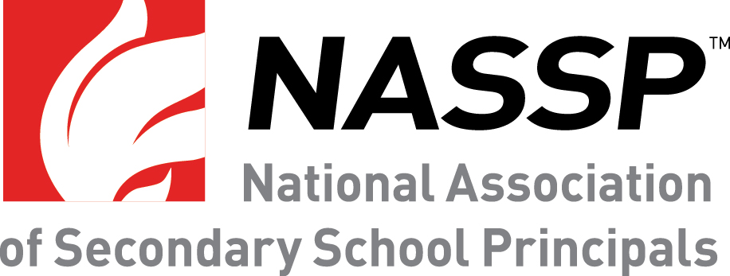
Three Top School Leaders Named Finalists for 2018 NASSP National Principal of the Year
Principals from SC, IL, and GA to be recognized at Principals Institute
FOR IMMEDIATE RELEASE
Contact:
Bob Farrace, NASSP Director of Public Affairs
farraceb@nassp.org, 703-909-4661
Reston, VA – Three principals—one from South Carolina, Illinois, and Georgia—are finalists for the National Association of Secondary School Principals (NASSP)’s 2018 National Principal of the Year (POY) award. They will be recognized at the Principals Institute on September 24–27, which will be attended by dignitaries, policymakers, and industry peers.
Jack Baldermann, Westmont High School, Westmont, IL, @Westmont201 (school)
Jack Baldermann has cultivated a culture of safety and compassion that has led to skyrocketing student achievement. His school was one of 500 nationwide that were chosen in 2015 by Newsweek for “Beating the Odds.” All African American and Latino students have graduated on time, four years in a row, and the number of underrepresented AP Scholars has increased by over 700 percent. Since 2015, the school has been the most improved regular high school in the nation on the Washington Post Challenge Index (and ranked top 1 percent in the state). The staff describe feeling supported by Baldermann, who has led them collaboratively in building ambitious, student-centered programs based on the school’s vision and S.M.A.R.T. goals. On top of faculty support and student success, Baldermann also believes in mentorship, having served as lead mentor to over 40 principals in 14 states. Additionally, in his 25 years as an administrator, 21 of the educators he hired and mentored for their first administrative position have gone on to become successful principals and superintendents.

Akil Ross, Chapin High School, Chapin, SC, @DrRossChapinHS
As an instructional leader, Akil Ross models best practices and consistently challenges faculty members to grow professionally, as he understands the important link between professional growth and student performance. Under Ross’s leadership, Chapin High School was recognized as a South Carolina Palmetto's Finest Award recipient in 2015. Not content with an 82 percent proficiency rates and 92 graduation rate, Ross challenged his faculty to aim for 100. That challenge sparked the analysis of trend data to identify student most at risk of dropping out, then soliciting funding for a “school after school” to extend instructional services for those students. Chapin’s graduation rate now exceeds 96 percent and proficiency rates continue to climb, including a 16-point spike in math proficiency among Black students. Ross’s mantra for the school is, “We are a thousand passions with one heartbeat,” and he aims to foster an environment where students can be challenged but also pursue their own interests.
Tommy Welch, Meadowcreek High School, Norcross, GA, @principalwelch
In his six years as principal at Meadowcreek High School (MHS), Tommy Welch took one of Georgia’s largest and lowest performing, yet most diverse urban school and raised the graduation rate from 47 to 73 percent. One teacher described Welch as embodying Muhammad Ali’s idea that “impossible is nothing!” and this is apparent in initiatives he has implemented, including the introduction of more STEM courses, project-based learning, on-campus internships with business partners and state politicians, and transforming the school into five smaller college- and career-theme learning centers. MHS has Georgia’s first full-service bank in a school, as well as a maker space designed in collaboration with Georgia Tech. The guiding principles that motivate his school improvement efforts are collaborate, inspire, and own—Welch uses these to empower students, staff, and the community to accomplish their goals and succeed.
“Each of these extraordinary school leaders has synchronized all the small improvements through the school to make sure they are building toward a large improvement,” stated NASSP Executive Director JoAnn Bartoletti. “The strides they have made in school improvement are evident in the engagement and success of their students and we honor them for these accomplishments.”
These three finalists will be recognized at the 2017 NASSP Principals Institute, an event that convenes all state principals from each of the 50 states, the District of Columbia, the U.S. Department of State Office of Overseas Schools, and the Department of Defense Education Activity. The institute will be held in Washington, D.C., September 24–27, 2017, and will involve a series of professional development activities and meetings with congressional members.

The National Principal of the Year will be announced in October during National Principals Month.
About the POY program
The NASSP Principal of the Year program honors State Principals of the Year from each of the 50 states, the District of Columbia, the U.S. Department of State Office of Overseas Schools, and the Department of Defense Education Activity. Out of these exceptional school leaders, three are selected as finalists and one is ultimately selected for the National Principal of the Year award. The award recognizes outstanding middle level and high school principals who have succeeded in providing high-quality learning opportunities for students as well as demonstrating exemplary contributions to the profession.
For more information on the POY program, please visit www.nassp.org/poy.
About NASSP
The National Association of Secondary School Principals (NASSP) is the leading organization of and voice for middle level and high school principals, assistant principals, and school leaders from across the United States. The association connects and engages school leaders through advocacy, research, education, and student programs. NASSP advocates on behalf of all school leaders to ensure the success of each student and strengthens school leadership practices through the design and delivery of high-quality professional learning experiences. Reflecting its long-standing commitment to student leadership development, NASSP administers the National Honor Society, National Junior Honor Society, National Elementary Honor Society, and National Association of Student Councils.

